**MICROLECTURE MOBILE LEARNING SYSTEM**

## A PROJECT REPORT

submitted by

**JABIN JALEEL**

**LLMC18MCA015**

## to

The APJ Abdul Kalam Technological University

in partial fulfillment of the requirements for the award of the Degree of

Master of Computer Applications



# Department of Computer Applications

## LOURDES MATHA COLLEGE OF SCIENCE AND TECHNOLOGY KUTTICHAL, THIRUVANANTHAPURAM

JULY 2021

**MICROLECTURE MOBILE LEARNING SYSTEM**

PROJECT REPORT

*Submitted by:*

JABIN JALEEL

**LLMC18MCA015**

to

*The APJ Abdul Kalam Technological University*

*in partial fulfillment of the requirements for the award of the degree*

*of*

*MASTER OF COMPUTER APPLICATIONS*

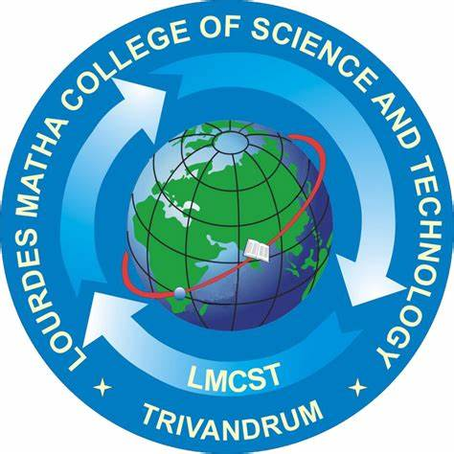

**DEPARTMENT OF COMPUTER APPLICATIONS**

**LOURDES MATHA COLLEGE OF SCIENCE AND TECHNOLOGY**

**KUTTICHAL, THIRUVANANTHAPURAM**

**DEPARTMENT OF COMPUTER APPLICATIONS**

**LOURDES MATHA COLLEGE OF SCIENCE & TECHNOLOGY, KUTTICHAL,**

**THIRUVANANTHAPURAM**



**CERTIFICATE**

This is to certify that the report entitled “**Microlecture Mobile Learning System**” submitted by **JABIN JALEEL** to the APJ Abdul Kalam Technological University in partial fulfillment of the requirements for the award of the Degree of Master of Computer Applications is a bonafide record of the project work carried out by him under my guidance and supervision.

Prof. Bismi K Charleys Mr. Kiran

(Internal Supervisor) (External Supervisor)

Prof. Neethu Mohan Date Prof. Selma Joseph

(Project Coordinator) (Head of the Dept.)

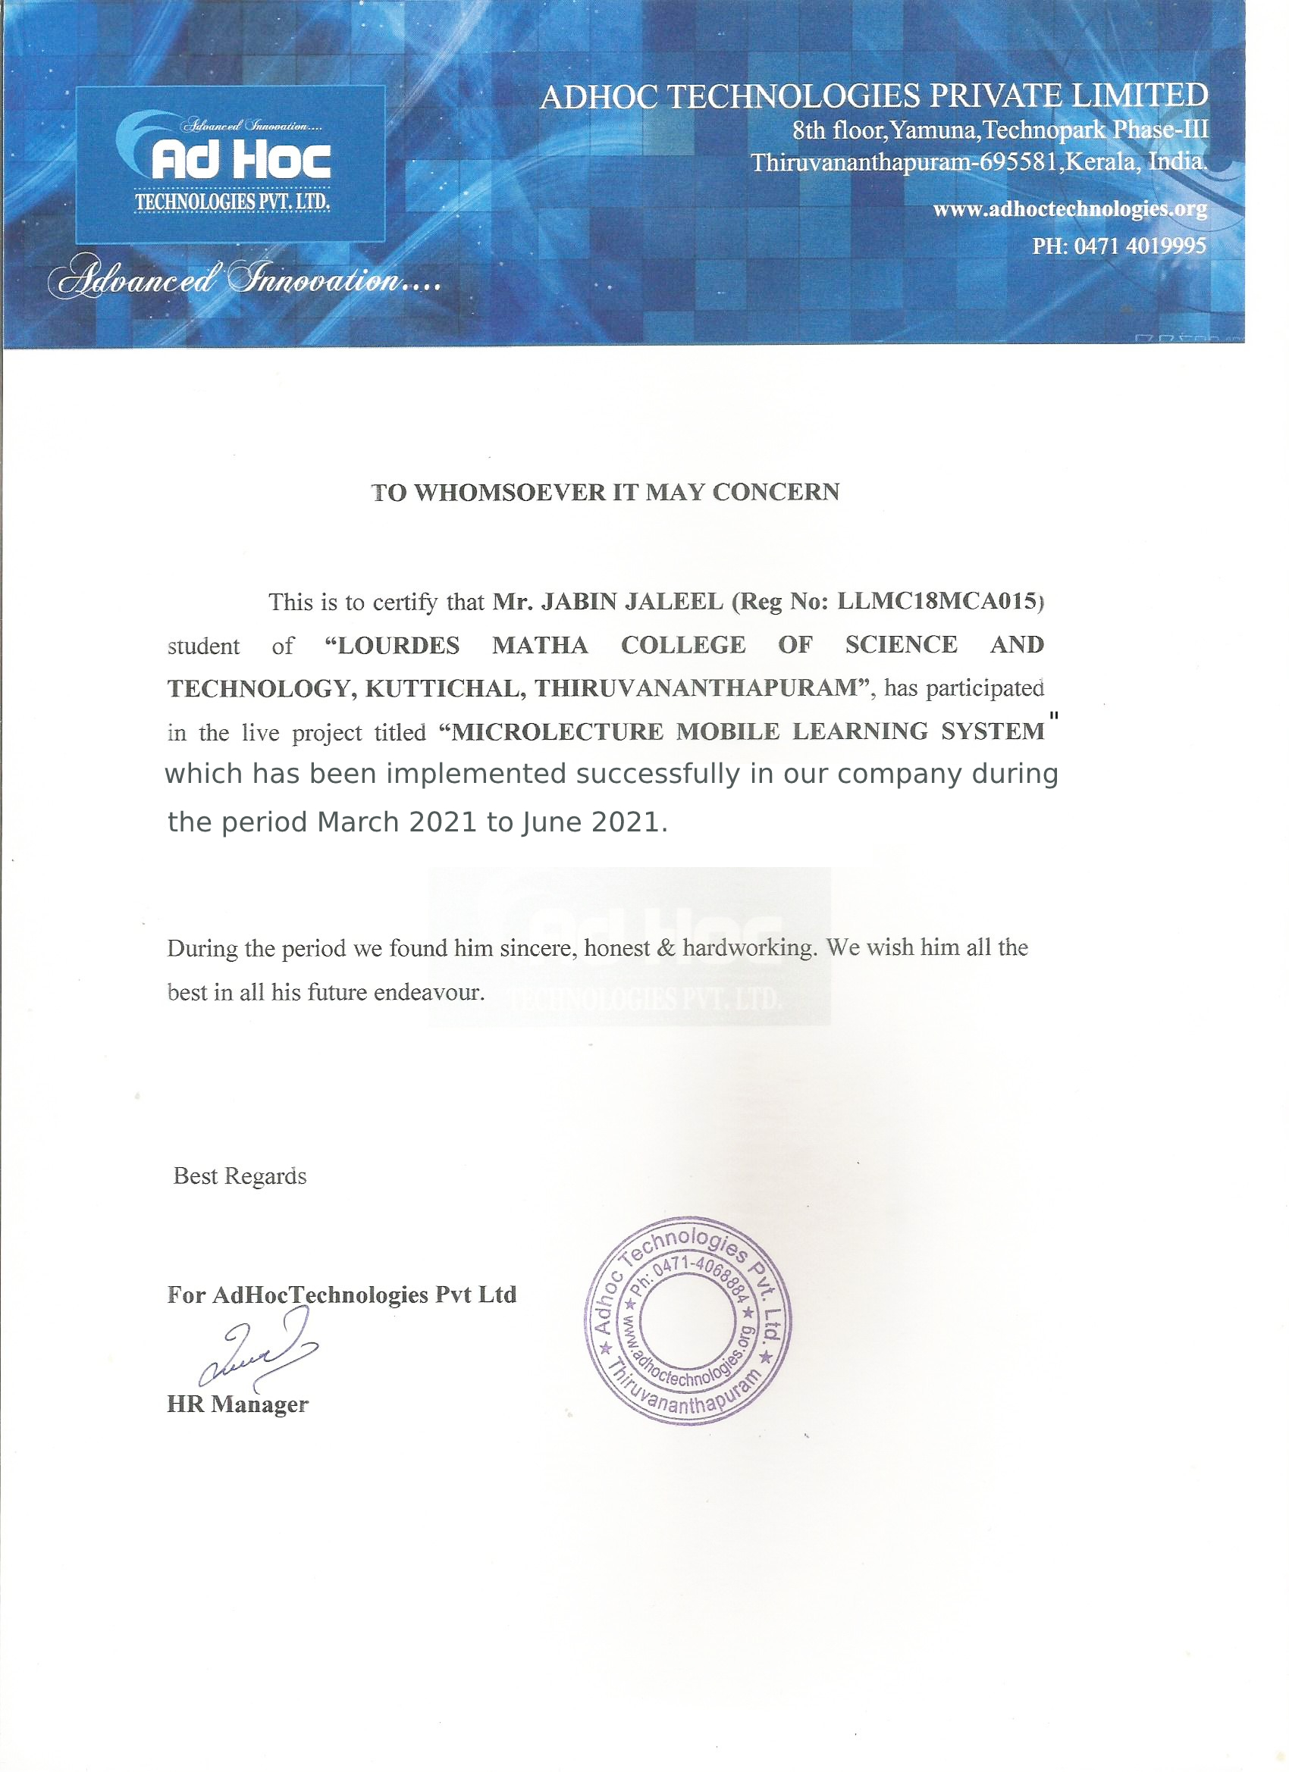

**DECLARATION**

I undersigned hereby declare that the project report “**Microlecture Mobile Learning System**” , submitted for partial fulfillment of the requirements for the award of degree of Master of Computer Applications of the APJ Abdul Kalam Technological University, Kerala is a bonafide work done by me under supervision of Prof. Bismi K Charleys. This submission represents my ideas in my own words and, I have adequately and accurately cited and referenced the original sources. I also declare that I have adhered to ethics of academic honesty and integrity and have not misrepresented or fabricated any data or idea or fact or source in my submission. I understand that any violation of the above will be a cause for disciplinary action by the institute and/or the University.

Place : Trivandrum

Date : 20/07/2020

**CONTENTS**

Contents Page No

ACKNOWLEDGMENT i

ABSTRACT ii

CHAPTER 1.......................................................................................……………………... 1

INTRODUCTION…………………………………………………………………………. 1

1.1 GENERAL INTRODUCTION………………………………………………... 2

1.2 GOAL OF THE PROJECT……………………………………………………. 2

CHAPTER 2………………………………………………………………………………. 3

LITERATURE STUDY…………………………………………………………… ……... 3

2.1 STUDY OF SIMILAR WORK………………………………………………... 4

2.1.1 Existing System……………………………………………………… 4

2.1.2 Drawback of Existing System……………………………………….. 4

CHAPTER 3……………………………………………………………………………….. 6

OVERALL DESCRIPTION……………………………………………………………….. 6

3.1 PROPOSED SYSTEM………………………………………………… ………7

3.2 FEATURES OF PROPOSED SYSTEM………………………………………. 7

3.3 FUNCTIONS OF PROPOSED SYSTEM……………………………………... 8

3.4 REQUIREMENT SPECIFICATION………………………………………….. 8

3.5 FEASIBILITY ANALYSIS AND STUDY…………………………………… 8

3.5.1 Technical feasibility………………………………………………….. 9

3.5.2 Operational Feasibility………………………………………………. 9

3.5.3 Economical Feasibility………………………………………………. 9

3.3.4 Behavioural Feasibility………………………………………………. 10

CHAPTER 4……………………………………………………………………………….. 11

OPERATING ENVIRONMENT………………………………………………………….. 11

4.1 HARDWARE REQUIREMENTS…………………………………………….. 12

4.2 SOFTWARE REQUIREMENTS……………………………………………… 12

4.3 TOOLS AND PLATFORMS………………………………………………….. 12

4.3.1 Dart…………………………………………………………………... 13

4.3.2 Flutter………………………………………………………………… 14

4.3.3 SQLite………………………………………………………………... 15

CHAPTER 5……………………………………………………………………………….. 16

DESIGN……………………………………………………………………………………. 16

5.1 SYSTEM DESIGN…………………………………………………………….. 17

5.1.1 Data Flow Diagram…………………………………………………... 18

5.1.2 Project DFD………………………………………………………….. 20

5.3 DATABASE DESIGN………………………………………………………… 26

5.4 INPUT DESIGN……………………………………………………………….. 34

5.5 OUTPUT DESIGN…………………………………………………………….. 34

5.6 PROGRAM DESIGN………………………………………………………….. 35

CHAPTER 6……………………………………………………………………………….. 36

FUNCTIONAL AND NON FUNCTIONAL REQUIREMENTS………………………… 36

6.1 FUNCTIONAL REQUIREMENTS…………………………………………… 37

6.2 NON-FUNCTIONAL REQUIREMENTS…………………………………….. 37

CHAPTER 7……………………………………………………………………………….. 38

TESTING…………………………………………………………………………………... 38

7.1 TESTING STRATEGIES……………………………………………………… 39

7.2 UNIT TESTING……………………………………………………………….. 39

7.3 INTEGRATION TESTING……………………………………………………. 39

7.4 SYSTEM TESTING…………………………………………… ………………40

7.5 TESTING RESULTS…………………………………………………………...41

CHAPTER 8……………………………………………………………………………….. 42

RESULT AND DISCUSSION…………………………………………………………….. 42

8.1 RESULTS(SALIENT FEATURES)…………………………………………... 43

8.2 SCREEN SHOTS……………………………………………………………….44

CHAPTER 9……………………………………………………………………………….. 54

CONCLUSION…………………………………………………………………………….. 54

9.1 SYSTEM IMPLEMENTATION………………………………………………. 55

9.2 CONCLUSION………………………………………………………………… 55

9.3 FUTURE ENHANCEMENT…………………………………………………...55

BIBLIOGRAPHY 56

1.WEBSITES 56

APPENDICES 57

1.LIST OF TABLES 57

2.LIST OF FIGURES 57

3. ABBREVIATION AND NOTATION 59

**ACKNOWLEDGEMENT**

An endeavor over a long can be successful only with advice and support of many well-wishers. I wish to place on record my profound indebtedness and gratitude to all those who have contributed directly or indirectly to make this project work a success.

At the very onset, I express my gratitude to God Almighty, who sheltered me under his protective wings and showered on innumerable blessings throughout the period of this Master of Computer Application Course.

It is a great pleasure to express my sincere gratitude to Rev. Dr.Tomy Joseph Padinjareveettil, Director and Prof. Dr. P.P. Mohanlal, Principal, Lourdes Matha College of Science and Technology for permitting to do this project with the fullest spirit.

I am highly obliged to Mrs. Selma Joseph, Head of the Department of Computer Applications, Lourdes Matha College of Science and Technology, for being the source of inspiration throughout the course and for her valuable guidance.

With heart full of thanks, I would like to take up this opportunity to wish my internal guide Mrs. Bismi K Charleys Assistant Professor and all staffs of department of computer applications for their endless support, encouragements and suggestions in various stages of the development of this project.

Finally, I wish to express my sincere gratitude to all our friends, who directly or indirectly contributed in this venture

i

**ABSTRACT**

The rise of mobile cloud computing technology has given a chance to develop various computationally intensive applications for mobile devices. To use this opportunity in education, a new Next Generation Classroom Learning (NGCL) method called “Quiz inline” in the video is introduced. In Micro lecture Mobile Learning System, the user interacts with the video by answering the quiz at the end of each concept rather than at the end. The context and the questions uploaded are converted into a video. The video starts playing and pauses when the question is displayed and resumes when the student answers the question. Video quizzes need to be streamed continuously even when multiple users access the same video. To achieve the goal, “Online Frame Selection” mechanism is used, where-in which the key frames are extracted and converted to video. In order to facilitate video transmission to the students without any delay, a Platform as a Service mobile cloud environment is used from where those videos and video-quizzes are stored and streamed. By applying computational offloading, the videos are streamed to a group of users in a classroom. In the proposed system user will use mobile application for e-learning. Online/offline video streaming will be available for each and every class, user interacts with the video by answering the quiz at the end of each concept rather than at the end. Also, there will be chatbot available for user to interact at each video session. Thus, user get a feel of live session with a tutor in each and every video class.

ii